Application Migration

🌟 Definition
# Source: AI Source: Provided by: [Data Path: Persons Table -> ID Column: 1, Name_En Column: Motasem Essam] -> From: [ChatGPT] on [6/7/2026]
Application Migration is the process of moving an application from one environment, platform, architecture, technology, or infrastructure to another while preserving its functionality.
The goal is to improve performance, scalability, maintainability, security, or cost efficiency.

🎯 Purpose
# Source: AI Source: Provided by: [Data Path: Persons Table -> ID Column: 1, Name_En Column: Motasem Essam] -> From: [ChatGPT] on [6/7/2026]
Application migration is performed to:
- Modernize applications
- Move to the cloud
- Improve scalability
- Reduce maintenance costs
- Upgrade technologies
- Improve security
- Support business growth

🧠 Simple Definition
# Source: AI Source: Provided by: [Data Path: Persons Table -> ID Column: 1, Name_En Column: Motasem Essam] -> From: [ChatGPT] on [6/7/2026]
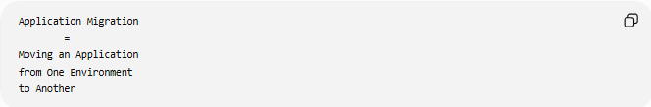
Application Migration
=
Moving an Application
from One Environment
to Another

📚 What Can Be Migrated?
# Source: AI Source: Provided by: [Data Path: Persons Table -> ID Column: 1, Name_En Column: Motasem Essam] -> From: [ChatGPT] on [6/7/2026]
An application consists of many components:
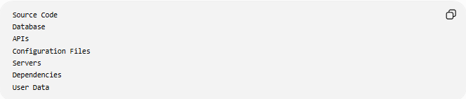
Source Code
Database
APIs
Configuration Files
Servers
Dependencies
User Data
During migration, one or more of these components may change.

🔍 Common Types of Application Migration

1️⃣ Platform Migration
# Source: AI Source: Provided by: [Data Path: Persons Table -> ID Column: 1, Name_En Column: Motasem Essam] -> From: [ChatGPT] on [6/7/2026]
Move an application to a different platform.
Example
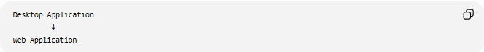
Desktop Application
↓
Web Application

Real Example
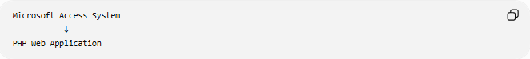
Microsoft Access System
↓
PHP Web Application
Benefits:
- Accessible from anywhere
- Multi-user support
- Easier updates

2️⃣ Cloud Application Migration
# Source: AI Source: Provided by: [Data Path: Persons Table -> ID Column: 1, Name_En Column: Motasem Essam] -> From: [ChatGPT] on [6/7/2026]
Move applications to the cloud.
Before
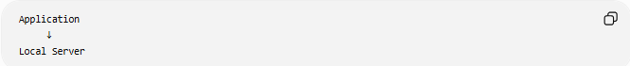
Application
↓
Local Server

After
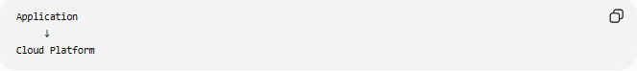
Application
↓
Cloud Platform
Examples:
- Amazon Web Services
- Microsoft
- Google

Benefits:
- Automatic scaling
- High availability
- Reduced hardware costs

3️⃣ Framework Migration
# Source: AI Source: Provided by: [Data Path: Persons Table -> ID Column: 1, Name_En Column: Motasem Essam] -> From: [ChatGPT] on [6/7/2026]
Move from one framework to another.
Example
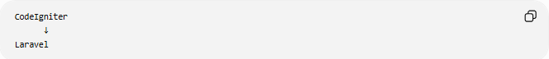
CodeIgniter
↓
Laravel
Or
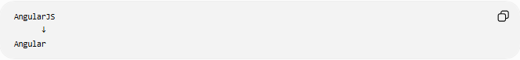
AngularJS
↓
Angular

Benefits:
- Better features
- Long-term support
- Improved performance

4️⃣ Technology Stack Migration
# Source: AI Source: Provided by: [Data Path: Persons Table -> ID Column: 1, Name_En Column: Motasem Essam] -> From: [ChatGPT] on [6/7/2026]
Move to a different technology stack.
Example
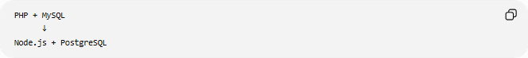
PHP + MySQL
↓
Node.js + PostgreSQL

Another example:
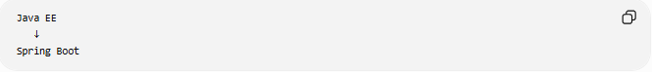
Java EE
↓
Spring Boot

5️⃣ Architecture Migration
# Source: AI Source: Provided by: [Data Path: Persons Table -> ID Column: 1, Name_En Column: Motasem Essam] -> From: [ChatGPT] on [6/7/2026]
Change application architecture.
Example
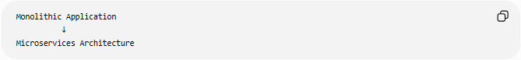
Monolithic Application
↓
Microservices Architecture

Before:
One Large Application
After:
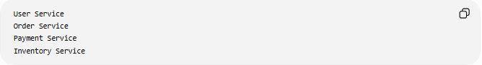
User Service
Order Service
Payment Service
Inventory Service

Benefits:
- Independent deployment
- Better scalability
- Easier maintenance

6️⃣ Operating System Migration
# Source: AI Source: Provided by: [Data Path: Persons Table -> ID Column: 1, Name_En Column: Motasem Essam] -> From: [ChatGPT] on [6/7/2026]
Move application to another operating system.
Example
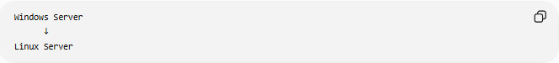
Windows Server
↓
Linux Server

Benefits:
- Lower licensing costs
- Better performance
- Better container support

🛠️ Real-World Example
# Source: AI Source: Provided by: [Data Path: Persons Table -> ID Column: 1, Name_En Column: Motasem Essam] -> From: [ChatGPT] on [6/7/2026]
Before Migration
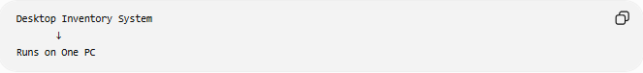
Desktop Inventory System
↓
Runs on One PC
Problems:
- Single-user
- No remote access
- Difficult updates

After Migration
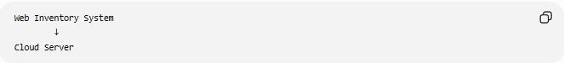
Web Inventory System
↓
Cloud Server
Benefits:
- Multi-user access
- Remote access
- Easier maintenance

🔄 Application Migration Lifecycle
# Source: AI Source: Provided by: [Data Path: Persons Table -> ID Column: 1, Name_En Column: Motasem Essam] -> From: [ChatGPT] on [6/7/2026]
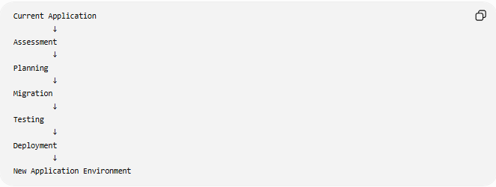
Current Application
↓
Assessment
↓
Planning
↓
Migration
↓
Testing
↓
Deployment
↓
New Application Environment

📦 Migration Strategies (The "6 Rs")
# Source: AI Source: Provided by: [Data Path: Persons Table -> ID Column: 1, Name_En Column: Motasem Essam] -> From: [ChatGPT] on [6/7/2026]
Rehost ("Lift and Shift")
Move application without major changes.
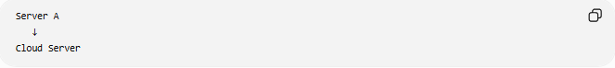
Server A
↓
Cloud Server
Fastest approach.

Replatform
Make small improvements while migrating.
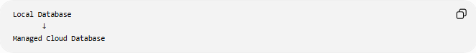
Local Database
↓
Managed Cloud Database

Refactor / Re-Architect
Redesign application structure.
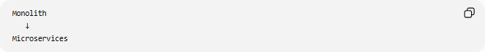
Monolith
↓
Microservices

Repurchase
Replace application entirely.
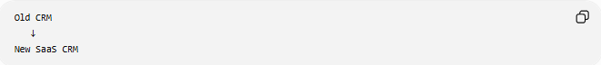
Old CRM
↓
New SaaS CRM

Retire
Remove unused applications.
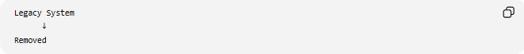
Legacy System
↓
Removed

Retain
Keep application unchanged for now.
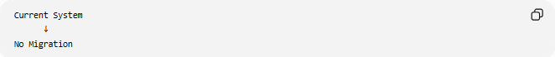
Current System
↓
No Migration

⚠️ Challenges of Application Migration
# Source: AI Source: Provided by: [Data Path: Persons Table -> ID Column: 1, Name_En Column: Motasem Essam] -> From: [ChatGPT] on [6/7/2026]
Possible issues:
- Downtime
- Data loss
- Compatibility problems
- Performance degradation
- Security risks
- User training requirements

✅ Best Practices
# Source: AI Source: Provided by: [Data Path: Persons Table -> ID Column: 1, Name_En Column: Motasem Essam] -> From: [ChatGPT] on [6/7/2026]
Assess First
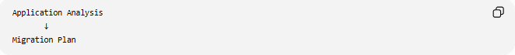
Application Analysis
↓
Migration Plan

Backup Everything
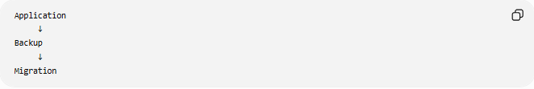
Application
↓
Backup
↓
Migration

Test Thoroughly
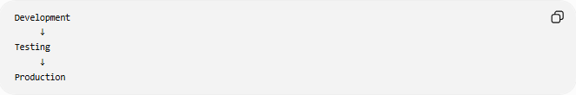
Development
↓
Testing
↓
Production

Migrate Incrementally
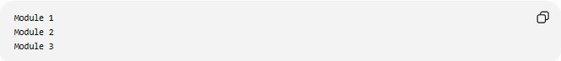
Module 1
Module 2
Module 3
instead of moving everything at once.

📊 Application Migration vs Database Migration
# Source: AI Source: Provided by: [Data Path: Persons Table -> ID Column: 1, Name_En Column: Motasem Essam] -> From: [ChatGPT] on [6/7/2026]
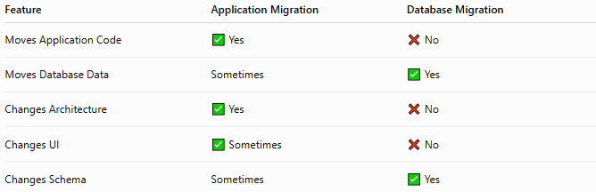
Feature | Application Migration | Database Migration
Moves Application Code | ✅ Yes | ❌ No
Moves Database Data | Sometimes | ✅ Yes
Changes Architecture | ✅ Yes | ❌ No
Changes UI | ✅ Sometimes | ❌ No
Changes Schema | Sometimes | ✅ Yes

🧠 Simple Analogy
# Source: AI Source: Provided by: [Data Path: Persons Table -> ID Column: 1, Name_En Column: Motasem Essam] -> From: [ChatGPT] on [6/7/2026]
Imagine a store.
Before
Small Physical Shop

Migration
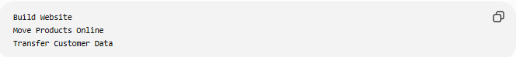
Build Website
Move Products Online
Transfer Customer Data

After
Online Store
The business remains the same, but the platform and operation have changed.

🧭 Summary
# Source: AI Source: Provided by: [Data Path: Persons Table -> ID Column: 1, Name_En Column: Motasem Essam] -> From: [ChatGPT] on [6/7/2026]
Application Migration is the process of moving an application from one environment, platform, architecture, framework, operating system, or technology stack to another. Common forms include platform migration, cloud migration, framework migration, technology stack migration, and architecture migration. The goal is to modernize applications, improve performance, reduce costs, and support future growth while maintaining functionality.

